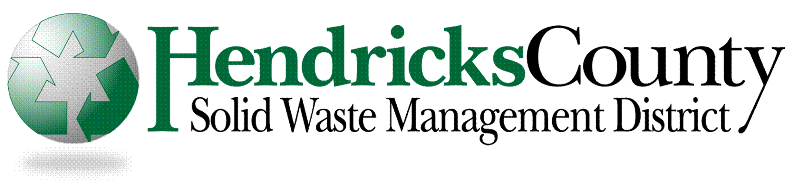
104 East Main Street
Brownsburg, IN 46112-1216
Phone: 317-858-6070 ● Fax: 317-858-6071
www.HendricksSolidWaste.com

Grant Application Summary and Cover Page

Organization Name______________________________________________________

Organization Address____________________________________________________

Contact Person_________________________Title_____________________________

Telephone Number______________________Fax Number______________________

Email Address__________________________________________________________

Website________________________________________________________________

Proposed Program/Project Title/Name______________________________________

Purpose of Program/Project_______________________________________________

_______________________________________________________________________

Total Cost of Program/Project_____________________________________________

Amount of Grant Request_________________________________________________

If program/project is not completely funded, can it be completed?_______________

_______________________________________________________________________

104 East Main Street
Brownsburg, IN 46112-1216
Phone: 317-858-6070 ● Fax: 317-858-6071
www.HendricksSolidWaste.com

Grant Application

Please answer the questions below about your organization and your proposed program/project:

1) Organization Information:
Briefly describe your organization. Include a mission statement and information on why it is an asset to the community.

2) Program/Project Information:
Describe the program/project for which you want financial support. Explain how the program/project will benefit your organization and further the mission of the Hendricks County Solid Waste Management District. Outline your plan to develop and execute the program/project.
- If the program/project involves recycling of materials, provide detailed information regarding how the logistics of the program/project will occur –How will recycling receptacles be monitored and emptied?
–Will a recycling contractor be involved? If so, how will those services be obtained?
–What steps will be taken to limit contamination of the recyclables?
- Provide an expense itemization and the total cost of your program/project.
–Explain which expenditures are most critical to the success of your project.

3) Project Evaluation:
Describe how will the success of your program/project be measured and what impact you expect to achieve. Explain how you estimated the impact your program/projects will have.

Required Attachments to the Application:
- A list of your organization’s Board of Directors, if applicable.
- A copy of your organization’s IRS 501 (c) (3) designation letter or tax exemption certificate.

Other Requirements:
- Applications may be mailed to:
Hendricks County Solid Waste Management District
104 East Main Street
Brownsburg, IN 46112-1216
- Application may also be submitted via email to:
Ldetwiler@HendricksSolidWaste.com
- Applications must be received by: March 13, 2015

